**XUANCHEN LIU**

**991486282**

1. **Output for SelectionSort-v1.c**

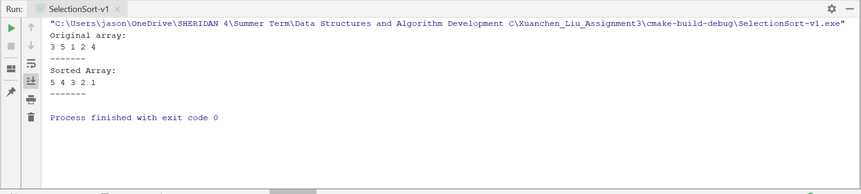

1. **Output for SelectionSort-v2.c**

